Front End Assignments
1. HTML
Q1. Write a program to design semantic and non-semantic tags with web
page form layout to get this desired output?
<!DOCTYPE html>
<html lang="en">
<head>
<meta charset="UTF-8">
<meta name="viewport" content="width=device-width, initial-scale=1.0">
<title>Question1</title>
</head>
<body>
<div style="width:60%;margin:auto;">
<header>
<h1>Welcome to my website!</h1>
<p>This is the home page of my website.</p>
</header>
<section>
<h2>About Me</h2>
<p>My name is John Doe and I'm a web developer</p>
<ol type="1">
<li>HTML5</li>
<li>CSS3</li>
<li>JavaScript</li>
</ol>
<table>
<tr>
<td>Row 1, Column 1</td>
<td>Row 1, Column 2</td>
</tr>
<tr>
<td>Row 1, Column 1</td>
<td>Row 1, Column 2</td>
</tr>
</table>
</section>
<section>
<h2>Control Me</h2>
<form>
<label>Name:</label><br>
<input type="text" name="name"><br><br>
<label>Email:</label><br>
<input type="email" name="email"><br><br>
<label>Message:</label><br>
<textarea rows="4" cols="30"></textarea><br><br>
<button type="submit">Send</button>
</form>
</section>
<footer>
<p>Write some content here</p>
<p>Write some more content here</p>
</footer>
</div>
</body>
</html

Output:
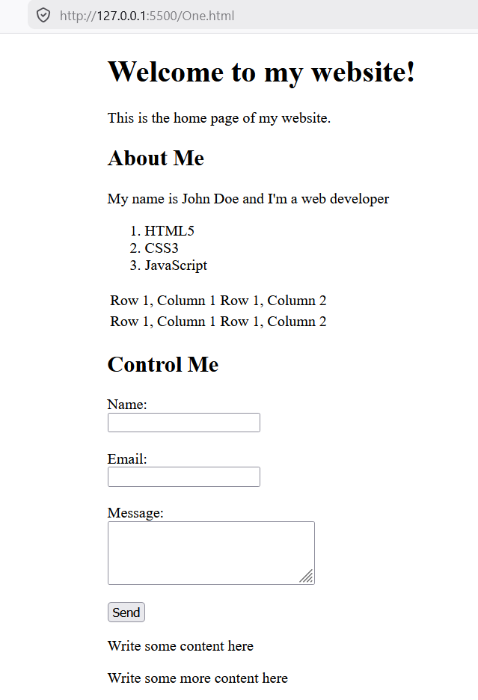
Q2.Write a program to display the menu card using table and using inline css
properties for color?
<!DOCTYPE html>
<html lang="en">
<head>
<meta charset="UTF-8">
<meta name="viewport" content="width=device-width, initial-scale=1.0">
<title>Menu Card</title>
<style>
* {
margin: 0;
padding: 0;
box-sizing: border-box;
font-family: Arial, sans-serif;
}

body {
background: #eee;
padding: 20px;
}

.menucard {
width: 1000px;
margin: auto;
border: 5px solid black;
background: #111;
color: gold;
}

.title {
text-align: center;
font-size: 28px;
font-weight: bold;
padding: 10px;
background: gold;
color: black;
border-bottom: 5px solid black;
}

.row {
display: flex;
}

.box {
width: 33.33%;
border: 3px solid black;
padding: 10px;
text-align: center;
}

.box h2 {
background: black;
color: gold;
padding: 5px;
margin-bottom: 10px;
border: 2px solid gold;
}

.box img {
width: 100%;
height: 150px;
object-fit: cover;
border: 2px solid gold;
margin-bottom: 10px;
}

table {
width: 100%;
border-collapse: collapse;
color: gold;
}

table, td {
border: 1px solid gold;
}

th {
color: #fff;
background: black;
padding: 5px;
}

td {
padding: 5px;
text-align: center;
}
</style>
</head>
<body>

<div class="menucard">
<div class="title">MENU CARD</div>

<div class="row">
<!-- Pure Veg -->
<div class="box">
<h2>PURE VEG</h2>
<img src="img/veg.jpg">
<table>
<tr><th>Menu</th><th>Price</th></tr>
<tr><td>Mutter Paneer</td><td>200</td></tr>
<tr><td>Shahi Paneer</td><td>220</td></tr>
<tr><td>Kaju Masala</td><td>220</td></tr>
<tr><td>Palak Paneer</td><td>180</td></tr>
<tr><td>Veg Kolhapuri</td><td>160</td></tr>
<tr><td>Dal Tadka</td><td>150</td></tr>
<tr><td>Bhendi Fry</td><td>170</td></tr>
</table>
</div>

<!-- Breads -->
<div class="box">
<h2>BREAD'S</h2>
<img src="img/breads.jpg">
<table>
<tr><th>Menu</th><th>Price</th></tr>
<tr><td>Tanduri Roti</td><td>20</td></tr>
<tr><td>Lachha Paratha</td><td>30</td></tr>
<tr><td>Butter Naan</td><td>25</td></tr>
<tr><td>Roomali Roti</td><td>10</td></tr>
<tr><td>Aloo Paratha</td><td>50</td></tr>
<tr><td>Plain Naan</td><td>20</td></tr>
<tr><td>Garlic Naan</td><td>30</td></tr>
</table>
</div>

<!-- Non Veg -->
<div class="box">
<h2>NON-VEG</h2>
<img src="img/non-veg.jpg">
<table>
<tr><th>Menu</th><th>Price</th></tr>
<tr><td>Butter Chicken</td><td>350</td></tr>
<tr><td>Kadai Chicken</td><td>250</td></tr>
<tr><td>Chicken Curry</td><td>300</td></tr>
<tr><td>Fish Curry</td><td>400</td></tr>
<tr><td>Egg Curry</td><td>150</td></tr>
<tr><td>Chicken Handi</td><td>270</td></tr>
<tr><td>Prawns Fry</td><td>450</td></tr>
</table>
</div>
</div>

<div class="row">
<!-- Rice -->
<div class="box">
<h2>RICE</h2>
<img src="img/rice.jpg">
<table>
<tr><th>Menu</th><th>Price</th></tr>
<tr><td>Jeera Rice</td><td>130</td></tr>
<tr><td>Veg Pulao</td><td>130</td></tr>
<tr><td>Plain Rice</td><td>90</td></tr>
<tr><td>Biryani</td><td>150</td></tr>
<tr><td>Tawa Pulao</td><td>100</td></tr>
<tr><td>Paneer Pulao</td><td>140</td></tr>
<tr><td>Mutter Pulao</td><td>140</td></tr>
</table>
</div>

<!-- Chinese -->
<div class="box">
<h2>CHINESE</h2>
<img src="img/chainese.jpg">
<table>
<tr><th>Menu</th><th>Full</th><th>Half</th></tr>
<tr><td>Noodles</td><td>140</td><td>70</td></tr>
<tr><td>Manchurian</td><td>130</td><td>65</td></tr>
<tr><td>Fried Rice</td><td>100</td><td>50</td></tr>
<tr><td>Machew Soup</td><td>90</td><td>-</td></tr>
<tr><td>Schezwan Chilli</td><td>160</td><td>80</td></tr>
<tr><td>Schezwan Noodles</td><td>160</td><td>80</td></tr>
<tr><td>Chicken Manchow Soup</td><td>170</td><td>90</td></tr>
</table>
</div>

<!-- South Indian -->
<div class="box">
<h2>SOUTH INDIAN</h2>
<img src="img/south_indian.jpg">
<table>
<tr><th>Menu</th><th>Price</th></tr>
<tr><td>Plain Dosa</td><td>35</td></tr>
<tr><td>Masala Dosa</td><td>45</td></tr>
<tr><td>Vada Sambar</td><td>40</td></tr>
<tr><td>Idli Sambar</td><td>50</td></tr>
<tr><td>Pulihora</td><td>110</td></tr>
<tr><td>Uttapa</td><td>70</td></tr>
<tr><td>Onion Dosa</td><td>60</td></tr>
</table>
</div>
</div>

</div>
</body
</html>
Output:

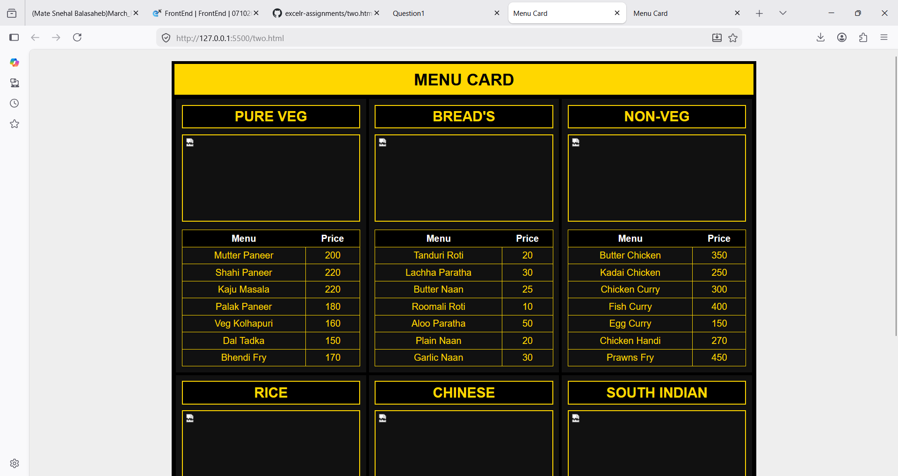
Q3.Write a program to show all form input controls in HTML5 as given
below?

<!DOCTYPE html>
<html lang="en">
<head>
<meta charset="UTF-8">
<meta name="viewport" content="width=device-width, initial-scale=1.0">
<title>Form Input Controls Example</title>

<style>
body{
font-family: Arial, sans-serif;
margin: 20px;
font-size: 14px;
}

.container{
width: 650px;
margin: auto;
border: 1px solid #ccc;
padding: 15px;
}

h2{
text-align: center;
margin-top: 0;
}

input, select, textarea{
padding: 3px;
margin: 3px;
}

.row{
margin-bottom: 12px;
}

textarea{
width: 250px;
height: 50px;
}
</style>
</head>
<body>

<div class="container">
<h2>Form Input Controls Example</h2>

<form>

<div class="row">
Name: <input type="text" placeholder="Name">
Password: <input type="password" placeholder="Password">
Email: <input type="email" placeholder="Email">
</div>

<div class="row">
Age: <input type="number" value="18" style="width:50px;">
Rating: <input type="range" value="50">
DOB: <input type="date">
</div>

<div class="row">
Time: <input type="time">
Image: <input type="file">
</div>

<div class="row">
Week: <input type="week">
Month: <input type="month">
</div>

<div class="row">
Datetime: <input type="datetime-local">
</div>

<div class="row">
URL: <input type="url" placeholder="https://">
Search: <input type="search" placeholder="Search">
</div>

<div class="row">
Gender:
<input type="radio" name="gender"> Male
<input type="radio" name="gender"> Female
</div>

<div class="row">
Interests:
<input type="checkbox"> Reading
<input type="checkbox" checked> Sports

Country:
<select>
<option>United States</option>
<option>India</option>
<option>UK</option>
</select>
</div>

<div class="row">
Message:<br>
<textarea placeholder="Enter your message"></textarea>
</div>

<div class="row">
<input type="submit" value="Submit">
<input type="reset" value="Reset">
</div>

</form>
</div>

</body>
</html>
```

Output:
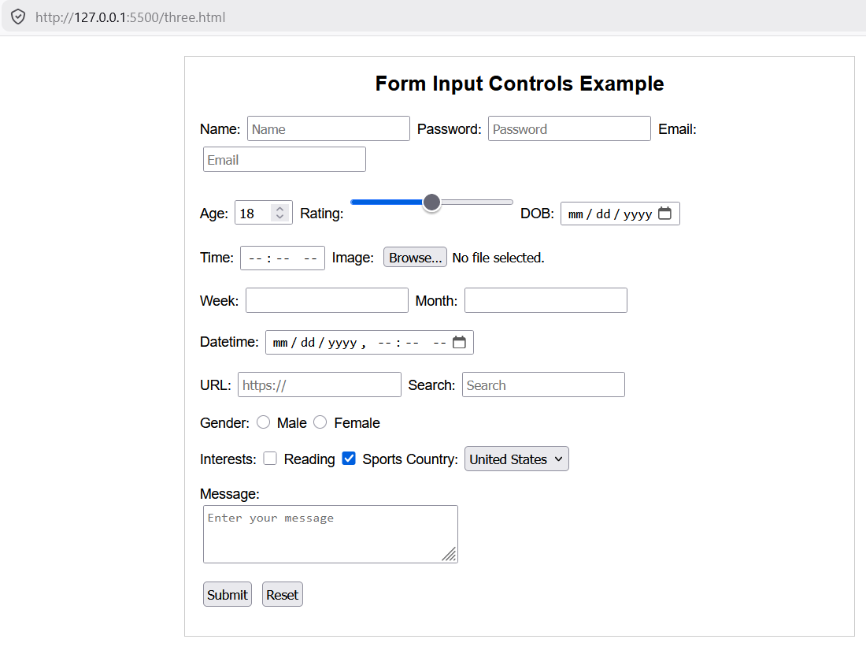

2.CSS
4.Design flipkart login page?

<!DOCTYPE html>
<html lang="en">
<head>
<meta charset="UTF-8">
<meta name="viewport" content="width=device-width, initial-scale=1.0">
<title>Login</title>

<style>
body{
margin: 0;
font-family: Arial, sans-serif;
background-color: #f1f3f6;
}

.container{
width: 800px;
height: 500px;
background: #fff;
margin: 50px auto;
display: flex;
}

.left{
width: 40%;
background: #2874f0;
color: white;
padding: 40px;
position: relative;
}

.left h1{
margin-top: 0;
margin-bottom: 20px;
}

.left p{
font-size: 16px;
line-height: 24px;
}

.left img{
width: 80%;
position: absolute;
bottom: 20px;
left: 30px;
}

.right{
width: 60%;
padding: 40px;
}

.right input{
width: 100%;
padding: 10px 5px;
margin-bottom: 25px;
border: none;
border-bottom: 1px solid #878787;
outline: none;
font-size: 14px;
}

.terms{
color: gray;
font-size: 12px;
line-height: 18px;
margin-bottom: 25px;
}

.terms a,
.bottom-text a{
text-decoration: none;
color: #2874f0;
}

.btn{
width: 100%;
padding: 12px;
background: #fb641b;
color: white;
border: none;
font-weight: bold;
cursor: pointer;
}

.bottom-text{
text-align: center;
margin-top: 120px;
font-size: 14px;
}
</style>
</head>
<body>

<div class="container">

<div class="left">
<h1>Login</h1>

<p>
Get access to your Orders,<br>
Wishlist and<br>
Recommendations
</p>

<img src="https://via.placeholder.com/250x150" alt="Login Image">
</div>

<div class="right">

<input type="text" placeholder="Enter Email/Mobile number">

<p class="terms">
By continuing, you agree to Flipkart's
<a href="#">Terms of Use</a> and
<a href="#">Privacy Policy</a>
</p>

<button type="button" class="btn">
Request OTP
</button>

<div class="bottom-text">
New to Flipkart?
<a href="#">Create an account</a>
</div>

</div>

</div>

</body>
</html>

Output:
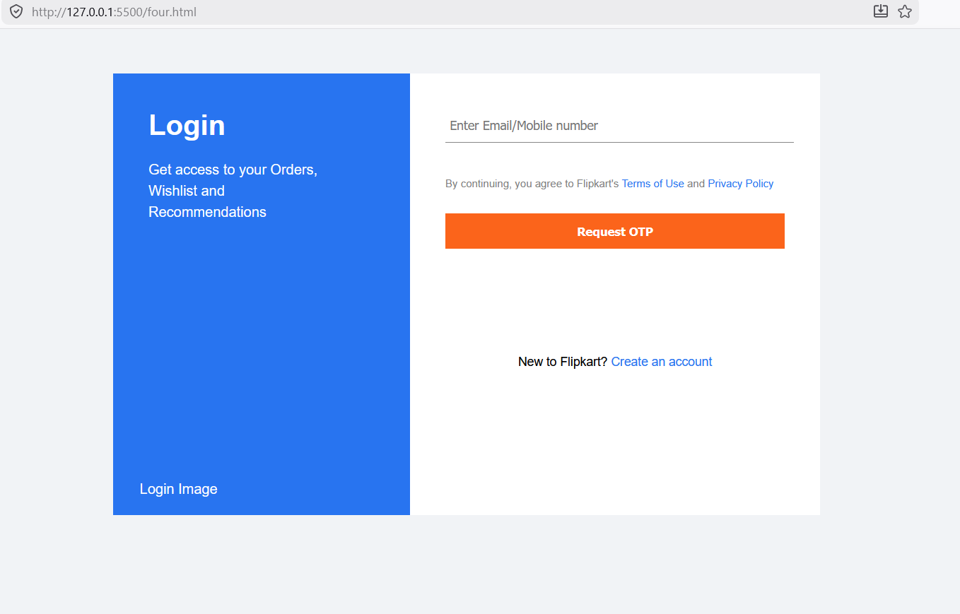

Q5.Write a program and display all flexbox properties?

<!DOCTYPE html>
<html lang="en">
<head>
<meta charset="UTF-8">
<meta name="viewport" content="width=device-width, initial-scale=1.0">
<title>Box Layout</title>

<style>
body{
margin: 0;
min-height: 100vh;
font-family: Arial, sans-serif;
background: linear-gradient(to right, #e96479, #8f50c7);
}

.container{
padding: 20px;
}

.row{
display: flex;
margin-bottom: 80px;
justify-content: space-between;
}

.bottom-row{
justify-content: space-around;
}

.box{
width: 180px;
height: 150px;
padding: 5px;
display: flex;
border: 2px solid #5a2a5a;
background: linear-gradient(to bottom right, #f6d365, #fda085);
}

.inner{
display: flex;
column-gap: 5px;
}

.small-box{
width: 45px;
height: 45px;
padding: 2px;
font-size: 10px;
color: #000;
background: linear-gradient(to bottom, #36d1dc, #000046);
}

/* Alignment Classes */
.top-left{
justify-content: flex-start;
align-items: flex-start;
}

.top-center{
justify-content: center;
align-items: flex-start;
}

.top-right{
justify-content: flex-end;
align-items: flex-start;
}

.bottom-left{
justify-content: flex-start;
align-items: flex-end;
}

.bottom-right{
justify-content: flex-end;
align-items: flex-end;
}

.center{
justify-content: center;
align-items: center;
}
</style>
</head>
<body>

<div class="container">

<!-- First Row -->
<div class="row">

<div class="box top-left">
<div class="inner">
<div class="small-box">Box1</div>
<div class="small-box">Box2</div>
<div class="small-box">Box3</div>
</div>
</div>

<div class="box top-center">
<div class="inner">
<div class="small-box">Box1</div>
<div class="small-box">Box2</div>
<div class="small-box">Box3</div>
</div>
</div>

<div class="box top-right">
<div class="inner">
<div class="small-box">Box1</div>
<div class="small-box">Box2</div>
<div class="small-box">Box3</div>
</div>
</div>

<div class="box top-left">
<div class="inner">
<div class="small-box">Box1</div>
<div class="small-box">Box2</div>
<div class="small-box">Box3</div>
</div>
</div>

<div class="box top-center">
<div class="inner">
<div class="small-box">Box1</div>
<div class="small-box">Box2</div>
<div class="small-box">Box3</div>
</div>
</div>

<div class="box top-right">
<div class="inner">
<div class="small-box">Box1</div>
<div class="small-box">Box2</div>
<div class="small-box">Box3</div>
</div>
</div>

</div>

<!-- Second Row -->
<div class="row bottom-row">

<div class="box center">
<div class="inner">
<div class="small-box">Box1</div>
<div class="small-box">Box2</div>
<div class="small-box">Box3</div>
</div>
</div>

<div class="box bottom-left">
<div class="inner">
<div class="small-box">Box1</div>
<div class="small-box">Box2</div>
<div class="small-box">Box3</div>
</div>
</div>

<div class="box center">
<div class="inner">
<div class="small-box">Box1</div>
<div class="small-box">Box2</div>
<div class="small-box">Box3</div>
</div>
</div>

<div class="box bottom-right">
<div class="inner">
<div class="small-box">Box1</div>
<div class="small-box">Box2</div>
<div class="small-box">Box3</div>
</div>
</div>

</div>

</div>

</body>
</html>

Output:
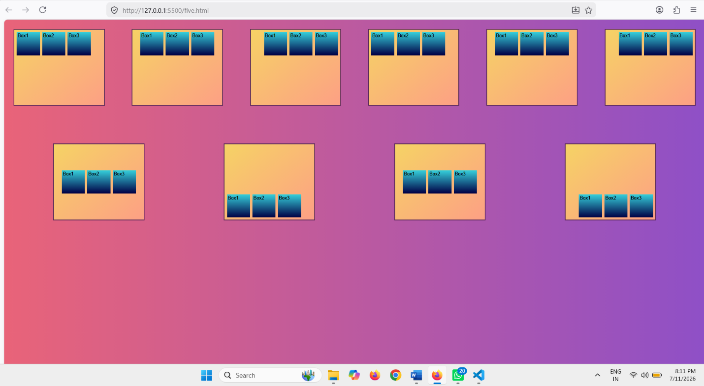

Q6.Write a program to design standard web layout using GRID?
<!DOCTYPE html>
<html>
<head>
<title>Grid Layout</title>
<style>
* {
margin: 0;
padding: 0;
box-sizing: border-box;
font-family: Arial, sans-serif;
}

.container {
display: grid;
grid-template-areas:
"header header"
"sidebar main"
"footer footer";
grid-template-columns: 250px 1fr;
grid-template-rows: 80px 1fr 60px;
height: 100vh;
}

.header {
grid-area: header;
background: #3b3b3b;
color: white;
display: flex;
justify-content: center;
align-items: center;
font-weight: bold;
}

.sidebar {
grid-area: sidebar;
background: #d3d3d3;
padding: 15px;
}

.main {
grid-area: main;
background: #e6e6e6;
padding: 15px;
}

.footer {
grid-area: footer;
background: #3b3b3b;
color: white;
display: flex;
justify-content: center;
align-items: center;
font-weight: bold;
}

h3 {
margin-bottom: 10px;
}

p {
font-size: 13px;
color: #555;
}

</style>
</head>
<body>

<div class="container">

<div class="header">Header</div>

<div class="sidebar">
<h3>Sidebar</h3>
<p>The Menu or quick access content.</p>
</div>

<div class="main">
<h3>Main Content</h3>
<p>The core website content should be displayed here.</p>
</div>

<div class="footer">Footer</div>

</div>

</body>
</html>

Output:
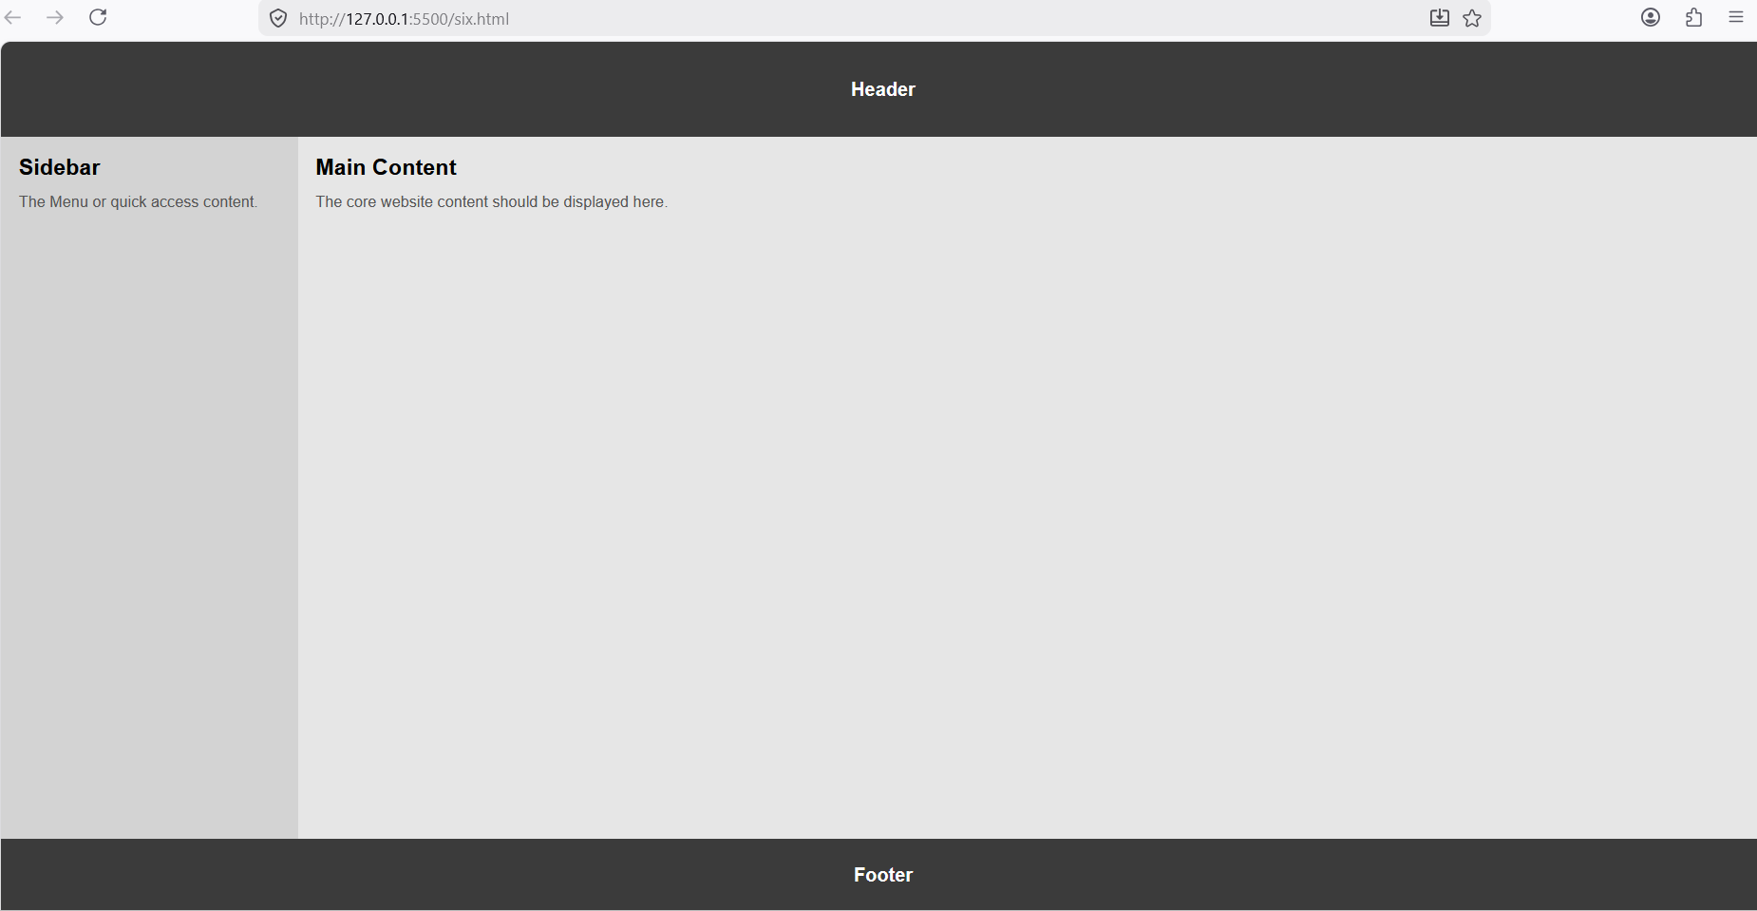
3. Java Script
Q7.Write a program to demonstrate JavaScript loops, operators and conditions?
<!DOCTYPE html>
<html>
<head>
<title>JavaScript Loops, Operators and Conditions</title>
</head>
<body>

<h2>Open Console (F12) to See Output</h2>

<script>
// Operators and Conditions
let num1 = 10;
let num2 = 5;

if (num1 > num2) {
console.log("Num1 is greater");
} else {
console.log("Num2 is greater");
}

// While Loop
let i = 1;
while (i <= 5) {
console.log("While loop iteration " + i);
i++;
}

// For Loop
for (i = 1; i <= 5; i++) {
console.log("For loop iteration " + i);
}

// Do-While Loop
i = 1;
do {
console.log("Do-While loop iteration " + i);
i++;
} while (i <= 5);

// Switch Condition
let day = 1;

switch (day) {
case 1:
console.log("It's Monday");
break;
case 2:
console.log("It's Tuesday");
break;
default:
console.log("Invalid Day");
}
</script>

</body>
</html>

Output:
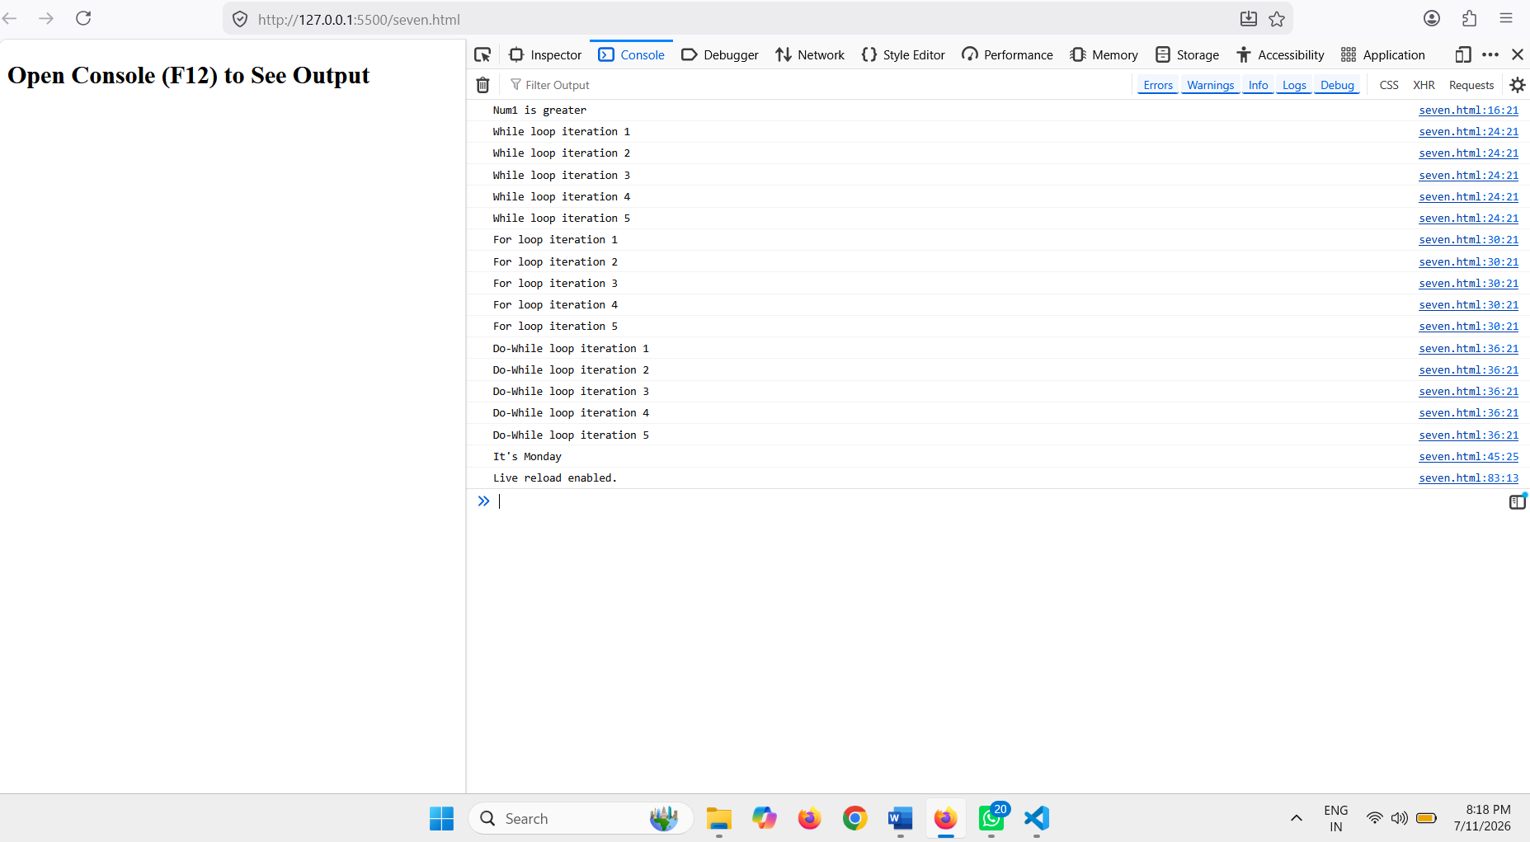

Q8. Write a program to create bulb design using dom model and provide functionality using function?
1)condition one: if click on button ask to color and display on bulb
2)condition two:if click off button display the bulb color white
<!DOCTYPE html>
<html lang="en">
<head>
<meta charset="UTF-8">
<meta name="viewport" content="width=device-width, initial-scale=1.0">
<title>Bulb ON/OFF</title>

<style>
*{
margin: 0;
padding: 0;
box-sizing: border-box;
}

body{
font-family: Arial, sans-serif;
}

.container{
width: 100vw;
height: 100vh;
display: grid;
place-items: center;
}

.main{
text-align: center;
}

.bulb{
width: 200px;
height: 200px;
border: 3px solid black;
border-radius: 50%;
background-color: white;
margin-bottom: 20px;
}

.button-container{
display: flex;
justify-content: center;
gap: 30px;
}

.btn{
width: 70px;
height: 40px;
border: none;
background-color: wheat;
cursor: pointer;
font-weight: bold;
}
</style>
</head>
<body>

<div class="container">
<div class="main">

<div class="bulb" id="bulb"></div>

<div class="button-container">
<button class="btn" onclick="turnOn()">ON</button>
<button class="btn" onclick="turnOff()">OFF</button>
</div>

</div>
</div>

<script>
const bulb = document.getElementById("bulb");

function turnOn() {
let bgColor = prompt("Enter bulb background color:");
bulb.style.backgroundColor = bgColor;
}

function turnOff() {
bulb.style.backgroundColor = "white";
}
</script>

</body>
</html>

Output:
